Disclaimer: I DO NOT claim or guarantee whether the answer written here is 100% accurate. If you feel something is not accurate or out-of-order or want to contribute, it will be a great help, if you let me know. Question which are crossed refers to the repeated question which has been answered already but this rule hasn’t been applied to all repeated question. Use Chrome to read this PDF properly. All question are from Pokhara University board exam papers of BCA.
Author: Pranav Bhattarai

Mobile Application Development Technology (Q&A)

Spring 2019
1 a) Explain Mobile OS and its structure with a diagram.
1 b) Explain DVM in details? Differentiate between JIT and AOT.
2 a) What do you understand by intent? Write down its syntax? Write down the program to switch from activity “Login Activity” o another activity “Dashboard Activity”.
2 b) What is activity in android? Explain the Android activity life-cycle with diagram.
3 a) Explain JVM. Why java is platform independent?
3 b) What do you mean by DPI? How can you achieve multiple screen support in our Android application? Explain.
4 a) Write an xml for login layout with username, password and login button using Linear Layout.
4 b) Describe processes, threads and broadcast receiver class in android.
5 a) What is alarm manager? What are the types of alarm?
5 b) Define multi-touch gesture in android? List and explain some of the events generated during multi-touch.
6 a) Define Sqlite Database. Write a sample sqlite code to create a database named “dictionary” in a public class DictinoryOpenHelper extending SQLiteOpenHelper.
6 b) Explain the steps on publishing an android app in Google Play Store.
7. Write short notes on any two:
a) Shared Preferences
b) User Notification
c) Inheritance in Java

Fall 2019

1 a) What is Mobile Application Development? Describe about scope of Mobile Application Development in Nepal.
Ans:
Mobile application development is the set of processes and procedures involved in writing software for small, wireless computing devices.

Scope of Mobile Application Development in Nepal is moderately fine.
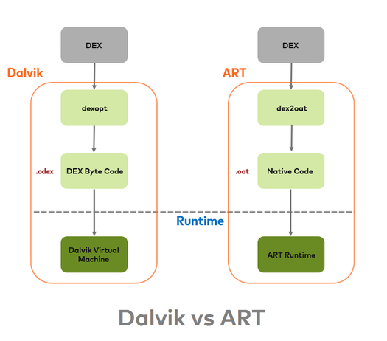
1 b) Explain DVM and android runtime in details? Difference between JIT and AOT.
Ans:
Dalvik Virtual Machine (DVM) is an interpreter-only virtual machine that executes files in the Dalvik Executable (.dex) format, a format that is optimized for efficient storage and memory-mappable execution. The virtual machine is register-based, and it can run classes compiled by a Java language compiler that have been transformed into its native format.

Android Runtime (ART) is an application runtime environment used by the Android operating system. This replaced the DVM from Android 5.

In Android Java classes, converted into DEX bytecode. The DEX bytecode format is translated to native machine code via either ART or the Dalvik runtimes. Here DEX bytecode is independent of device architecture.

Dalvik is a JIT (Just in time) compilation based engine. Android 7.0 adds a just-in-time (JIT) compiler with code profiling to Android runtime (ART) that constantly improves the performance of Android apps as they run.
The figure at the side explains the difference in DVM and ART in functioning.

The difference between JIT and AOT are enlisted below:
JIT | AOT
JIT stands for Just in Time which is a compilation technique where JIT compiler compile the Dalvik bytecode into machine code in an android ecosystem. | AOT stands Ahead of time which is a compilation technique where AOT compiler DEX byte code into machine code in an android ecosystem. (.dex is dalvik executable).
Dalvik use JIT compilation. | ART uses AOT compilation.
JIT speed is slower in due to JIT compilation. | With no need for JIT compilation, the code executes much faster.
Since JIT compiles only a part of the code, it has a smaller memory footprint and uses less physical space on the device. | As the native machine code generated on installation is stored in internal storage, more internal storage is required.

2 a) Explain about basic tools used to develop an Android app? Write a simple program to display ‘Hello android’.
Ans:
Basic tools used to develop an android app are enlisted below:
i) IDE : It stands for Integrated Development Environment is a software application that provides comprehensive facilities to computer programmers for software development. An IDE normally consists of at least a source code editor, build automation tools, and a debugger. Whether its Android Studio, Eclipse, IntelliJ, Netbeans etc, an IDE is a important assets to build and testing program any program just, not just android. If you install Android Studio which is make by Google, user don’t have to do anything complex inorder to make their IDE compatible for Android development.

ii) JDK: It stands for Java Development Kit. Even if the developer choose Kotlin programming language instead of Java, Without JDK installed we can’t use Java resources to compile the program in the first place.

iii) Internet: If the IDE selected by the user isn’t Android Studio, then he/she may need internet to access all plugins, artifacts and jar files required to setup android development. Even Android Studio, might need some updated plugins to setup which is only possible to fetch if there is internet connection. I think its really helpful to kick-start the android development if you have a internet access.

iv) A laptop with at least 8 GB of RAM: Android Studio itself cross 1 GB when you have to download. And after installation, it usually consumes over 2GB RAM. And the size is increasing every year. In fact if you carefully look into android studio official page, they have mentioned this. Far faster execution, one might need 16 GB of RAM which is an insane amount for people who can’t afford.
This four components is as basic as it get. There are lot other advance tools which can help in android development. This are the basic one which is require for anyone to start.

A simple program to display ‘hello android’ is written below:
//Hello world program

2 b) What are the features of OOP? Difference between an interface and an abstract class with Example.
Ans: The features of OOP are enlisted below:
i) Encapsulation
It refers to the creation of self-contained modules that bind processing functions to the data. These user-defined data types are called “classes”, and one instance of a class is an “object”. For example, in a payroll system, a class could be Manager, and Pat and Jan could be two instances (two objects) of the Manager class. Encapsulation ensures good code modularity, which keeps routines separate and less prone to conflict with each other.

ii) Inheritance
Classes are created in hierarchies, and inheritance allows the structure and methods in one class to be passed down the hierarchy. That means less programming is required when adding functions to complex systems. If a step is added at the bottom of a hierarchy, only the processing and data associated with that unique steps needs to be added. Everything else is inherited. The ability to reuse existing objects is considered a major advantage of object technology.

iii) Polymorphic
Object-oriented programming allows procedures about objects to be created whose exact type is not known until runtime. For example, a screen cursor may change its shape from an arrow to a line depending on the program mode. The routine to move the cursor on screen in response to mouse movement would be written for “cursor”, and polymorphism allows that cursor to take on whatever shape is required at runtime. It also allows new shapes to be easily integrated.

The difference an interface and an abstract class with example:
Interface | Abstract class
Variable declared in interface is by default final. | It may contain non-final variable.
Member of java interface are public by default. | It can have class member like private, protected, etc.
“Implements” keyword is used to implement interface. | “Extends” keyword is used to extend abstract class.
Interface is absolutely abstract and cannot be instantiated. | It is also cannot be instantiated but can be invoked if a main() exits.

3 a) List out dialog box which is supposed by Android? Explain two of them with example.
Ans: A dialog is a small window that prompts the user to make a decision or enter additional information. A dialog does not fill the screen and is normally used for modal events that require users to take an action before they can proceed.

Any two of them are:
i) AlertDialog
A dialog that can show a title, up to three buttons, a list of selectable items, or a custom layout.
import android.support.v7.app.AlertDialog;
public class MainActivity extends AppCompatActivity {
public void showAlertDialogButtonClicked(View view) {

// setup the alert builder
AlertDialog.Builder builder = new AlertDialog.Builder(this);
builder.setTitle("My title");
builder.setMessage("This is my message."); // add a button
builder.setPositiveButton("OK", null); // create and show the alert dialog
AlertDialog dialog = builder.create();
dialog.show();
}
}

ii) DatePickerDialog or TimePickerDialog
A dialog with a predefined UI that allows the user to select a date or time.
//code here

3 b) What is Activity and Fragment in android? Explain the Fragment life-cycle of android.
Ans:
Activity performs actions on the screen. If we want to do any operations, we have to with activity.

Fragment is a piece of activity, which can be used to turn our application 360 degrees, and so on.
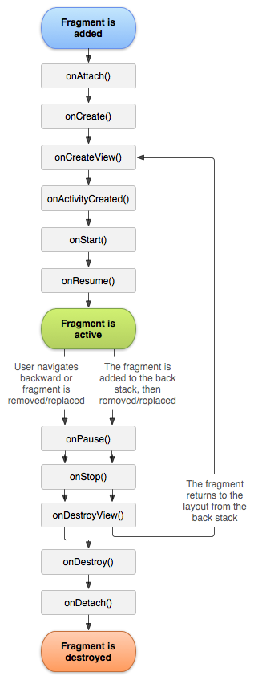

In short:
onAttach()
OnCreate()
onCreateView()
onActivityCreated()
onStart()
onResume()
onPause()
onStop()
onDestroyView()
onDestroy()
onDetach()

Fig: Life cycle of fragment (while is activity is running)

4 a) Describe about AsyncTask class in android. Write program to upload image in database using AsyncTask?
AsyncTask class is a class that extends the object class to allow short operations to run asynchronously in the background.
//code here

4 b) What is ListView? How you implement it in an android application?
Android ListView is a view which contains the group of items and displays in a scrollable list. ListView is implemented by importing android.widget.ListView class.
package com.example.ListDisplay;

import android.os.Bundle;
import android.app.Activity;
import android.view.Menu;
import android.widget.ArrayAdapter;
import android.widget.ListView;

public class ListDisplay extends Activity {
// Array of strings...
String[] mobileArray = {"Android","IPhone","WindowsMobile","Blackberry",
"WebOS","Ubuntu","Windows7","Max OS X"};

@Override
protected void onCreate(Bundle savedInstanceState) {
super.onCreate(savedInstanceState);
setContentView(R.layout.activity_main);

ArrayAdapter adapter = new ArrayAdapter<String>(this,
R.layout.activity_listview, mobileArray);

ListView listView = (ListView) findViewById(R.id.mobile_list);
listView.setAdapter(adapter);
}
}

5 a) What is multi touch in android? List and explain some of the events generated during multi-touch.

5 b) Explain different techniques to work with graphics in android. How you implement media player in an android application?
6 a) What is Google MobileAds SDK? Write step to implement it?
6 b) Explain about APK? Describe the methods of App Monetization?
Android Package (APK) is the package file format used by the Android operating system for distribution and installation of mobile apps and middle-ware. To make an APK file, a program for Android is first compiled, and then all of its parts are packaged into one container file. An APK file contains all of a program's code (such as .dex files), resources, assets, certificates, and manifest file. As is the case with many file formats, APK files can have any name needed, provided that the file name ends in the file extension ".apk".

7. Write shorts on any two:
a) Inner Class
Nested classes are called inner classes.

Inner classes can have all the features of a regular class, but their scope is limited. Inner classes have another benefit: they have full access to the class in which they are nested—this feature makes inner classes perfect for implementing adapter functionality like iterators.
public class User {

// User fields, including variables of type LoginInfo and UserPreferences
// Misc user methods

class LoginInfo
{
// Login info fields
// Login/Logout methods
// Can access User fields/methods
}

class Preferences
{
// User preference fields
// Get/Set preference methods
// Reset preferences method
// Can access User fields/methods
}
}
In this example, the User class has two inner classes: LoginInfo and Preferences. While all user-related data and functionality could be defined in the User class, using the inner classes to compartmentalize functionality can make code easier to read and maintain. The inner classes LoginInfo and Preferences also have access to the protected/private fields and methods available within the User class, which they might not otherwise have due to security, if they were defined as stand-alone classes themselves.

It’s important to remember, though, that inner classes really only exist to help the developer organize code; the compiler treats inner classes just like any other class, except that the inner classes have a limited scope, and are therefore tethered to the class they are defined with. Said another way, you would not be able to use or instantiate the LoginInfo or Preferences classes except with an instance of the User class, but the inner classes could access any fields or methods available in the outer class User, as needed.

b) Shared Preferences
Android provides many ways of storing data of an application. One of this way is called Shared Preferences. Shared Preferences allow you to save and retrieve data in the form of key,value pair.

In order to use shared preferences, you have to call a method getSharedPreferences() that returns a SharedPreference instance pointing to the file that contains the values of preferences.

SharedPreferences sharedpreferences = getSharedPreferences(MyPREFERENCES, Context.MODE_PRIVATE);

c) Array Adapter
In Android development, any time we want to show a vertical list of scrollable items we will use a ListView which has data populated using an Adapter . The simplest adapter to use is called an ArrayAdapter because the adapter converts an ArrayList of objects into View items loaded into the ListView container.

ArrayAdapter can use this adapter to provide views for an AdapterView, returns a view for each object in a collection of data objects you provide, and can be used with list-based user interface widgets such as ListView or Spinner.

Spring 2018
1 a) Explain in details about Mobile OS structure. Which kernel does iOS use?

1 b) Compare Native, HTML5 and Hybrid application development environment highlighting their pros and cons.
2 a)
i) What is android manifest XML? Write its usage. 2Marks
ii) What is view class and Snackbar in android? 2
iii) Explain in brief about SQLLite features. 4
2 b) What do mean by Object and Class in Java? Write a program to implement hierarchical inheritance in Java.
3 a) What do you mean by Intent? Explain its types with suitable program for each.

3 b) What is fragment? Explain its types with suitable program for each.
A fragment is a piece of an activity which enable more modular activity design. It is kind of sub-activity. IT represent multiple screen in one activity.

Its types are enlisted below:
- Single frame fragment:
They are used for hand hold devices like mobiles, here we can show only one fragment as a view.

//Code here

- List fragment
They are an important UI structure which assist in rendering list and grid data in Android.
package com.listexample.app;

public class ExampleListItem {

private String itemTitle;

public String getItemTitle() {
return itemTitle;
}

public void setItemTitle(String itemTitle) {
this.itemTitle = itemTitle;
}

public ExampleListItem(String title){
this.itemTitle = title;
}
}

- Fragments transaction
By using this we can move one fragment to another fragment.
//Code here

4 a) What do you mean by Density Independent Pixel? How can you achieve multiple screen support in our Android application? Explain.

4 b) What is spinner in android UI? Write in brief about Linear Layout, Relative Layout and Table Layout with suitable example.
5 a) What is Broad Cast Receiver Class? How is it used explain with a program?
5 b) Write an application that demonstrates how to preform operation using AsynTask on a background thread.

Fall 2017

1 a) Explain different types of mobile OSes?

1 b) Discuss about abstract class in Java?

2 a) Explain the application lifecycle of an activity.

2 b) What is Android Manifest.XML? Write its usage with appropriate example.

3 a) Explain implicit intent with example.

3 b) Define screen resolution, pixel density, screen orientation and screen size.

4 a) Point out the differences between broadcast receivers and services.

4 b) Define android layout and its types.

5 a) What is a toast class? Write an example for creating notification.

5 b) How do you publish application in play store?

6 a) Describe the methods of App Monetization?

6 b) How basic animation is done in Android?

7. Write short notes on any two: (2x5)

a) Native Vs HTML files

b) Fragment

c) Android Architecture
is a software stack of components to support a mobile device needs. Android software stack contains a Linux Kernel, collection of C/C++ libraries which is exposed through an application framework services, runtime and application.

Following are main components of android architecture those are:
- Applications
- Android Framework
- Android Runtime
- Platform Libraries
- Linux Kernel

In these components Linux Kernel is the main component in android to provide its OS functions to mobile and Dalvik Virtual Machine (DVM) which is responsible for running a mobile application.

Following is the pictorial representation of android architecture with different components:
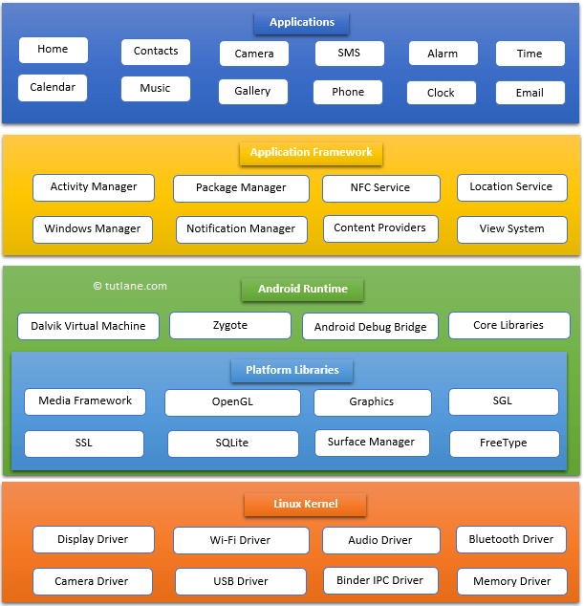
Applications:
The top layer of android architecture is Applications. The native and third party application like contacts, email, music, gallery, clock, games, etc. whatever we will built those will be installed on this layer only.

The application layer runs within the Android run time using the classes and services made available from the application framework.

Application Framework:
It provides the classes used to create an Android applications. It also provides a generic abstraction for hardware access and manages the user interface and application resources. It basically provides the services through which we can create the particular class and make that class helpful for the Application creation.

The application framework includes services like telephony services, location services, notification manager, NFC service, view system, etc. which we can use for application development as per our requirements.

Android Runtime:
Android Runtime environment is an important part of Android rather than an internal part and it contains a components like core libraries and the DVM. The Android run time is the engine that powers our applications along with the libraries and its forms the basis for the application framework.

Dalvik virtual machine (DVM) is a register-based virtual machine like Java Virtual Machine (JVM). It is specially designed and optimized for android to ensure that a device can run multiple instances efficiently. It relies on Linux kernel for threading and low-level memory management.

The core libraries in android runtime will enable us to implement an android application using standard Java programming language.

Platform Libraries:
It includes various C/C++ core libraries and java based libraries such as SSL, libc, Graphics, SQLite, Webkit, Media, Surface Manager, OpenGL, etc. to provide a support for android development.

Following are the summary details of some core android libraries available for android development.

- Media library for playing and recording an audio and video formats.
- The Surface manager library to provide a display management.
- 5GL and OpenGL Graphics libraries for 2D and 3D graphics.
- SQLite is for database support and FreeType for font support
- Web-Kit for web browser support and SSL for internet security.

Linux Kernel:
It is a bottom layer and heart of the android architecture. It management all the drivers such as display drivers, camera drivers, Bluetooth drivers, audio drivers, memory drivers, etc. which are mainly required for the android device during the runtime.

The Linux Kernel will provides an abstraction layer between the device hardware and the remainder of the stack. It is responsible for memory management, power management, device management, resource access, etc.
Spring 2017

1 a) What is android? Write brief history of Android.

1 b) List Android API version. What is Latest Android API version? What API version should your app would need to support maximum users? Explain.

2 a) What do you understand by intent? Write down its syntax? Write down the program to switch from activity “Login Activity” to another activity “Dashboard Activity”.

2 b) What is activity in Android? Explain the activity lifecycle with diagram.

3 a) What do you understand by views in android? Explain following:
i. Edit Text
ii. Spinner
iii. Progress Bar
iv. Orientation in Linear Layout

3 b) How to work with multiple screens in android. Explain with use cases as possible.

4 a) Write down the advantages and disadvantages of android operating system. Explain alert dialog box.

4 b) Explain the following properties of views:
i. android:visibility=”gone”
ii. android:text= “@string/Login”
iii. android:layout_width=”match_parent”
iv. android:hint=”@string/Address”
v. android:layout_height=”warp_content”
vi. android:textColor=”@color/black”
vii. android:inputType=”phone”
viii: android:id=”id/etxtMobileNumber”
ix. android:gravity=”center”
x. android:background=”@color/green”

5 a) Write down the XML for following using relative layout.

Enter your first name:
Enter last name:
Desired Username:
Enter password
Re-enter password
Enter Valid Email ID (Optimal)

Register

5 b) Which would you prefer database or shared preference for persistence storage.

6 a) Write code for button click listener to switch to another activity.

6 b) What is Toast Notification? How does it differ from status bar Notification? Write a sample code to display a toast Notification when an activity is started.

7. Write short notes on any two:

a) Google Play Services
b) Debug Apk vs Release Apk
c) Android App Monetization

2015 Spring

1 a) Define Mobile Phone and its OS. Android OS differ from iOS and Windows phone.
1 b) Differentiate between Native apps and HTML 5 apps.
2 a) Define inheritance and explain different types of inheritance.
2 b) How will you create intent? State steps with example.
3 a) Define Android Manifests File. How do you create the default activity in android?
3 b) What is the difference between resolution and density independent pixel? State the relationship between pixel, dp and dpi.
4 a) What is User Interface? Explain any two UI controls provided by the eclipse IDE for android.
4 b) What is notification manager? How do you create a new notification?
5 a) How many types of Animation supported in Android? For what purpose the Tweened animation used for? Write the XML code for defining an interpolated View Animation.
5 b) Explain any two macro-states of Android Media Player.
6 a) Discuss about the use of SQ Lite database. Explain methods of SQLiteOpenHelper class.
6 b) How is signing is debugging mode differ from signing in release mode? Explain.
7. Write short notes on any two:
a) Fragment Class
b) Broadcast Receiver Class
c) Alarms

